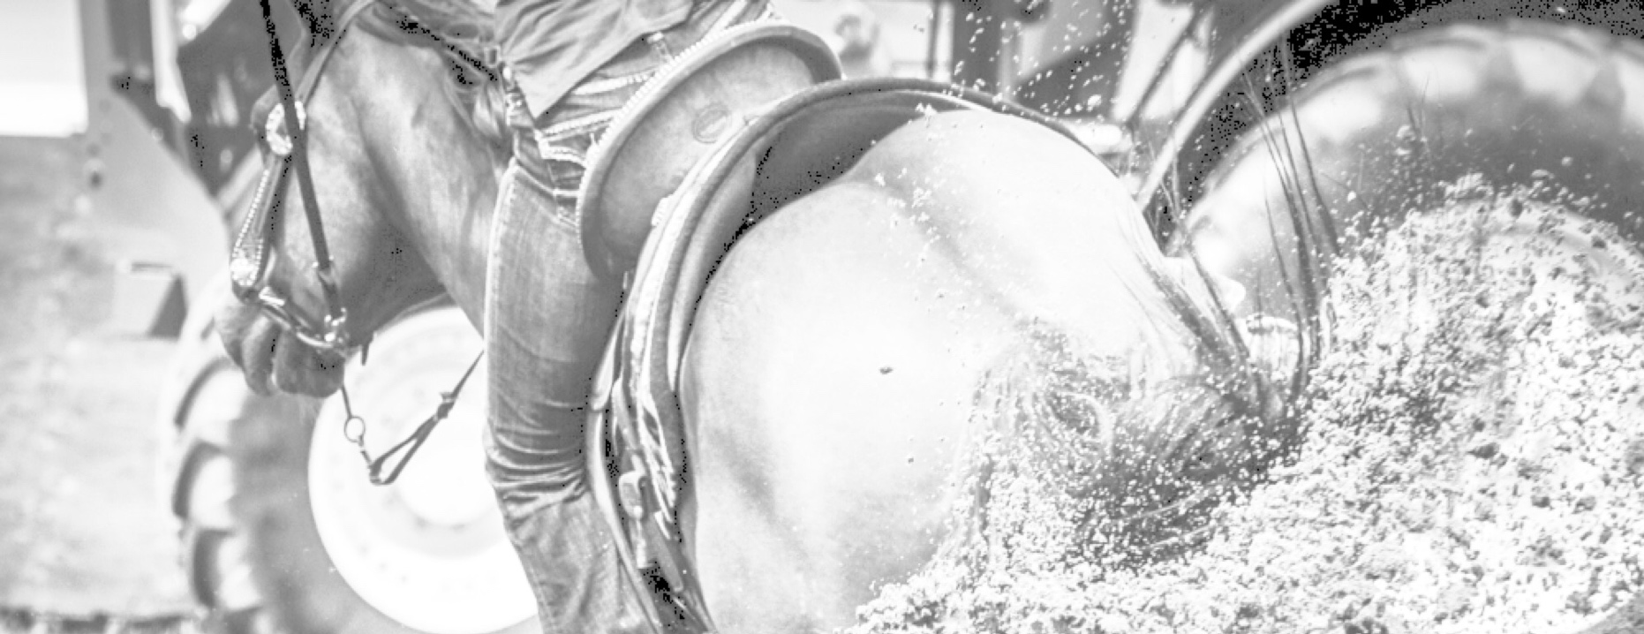
***WIN $50,000***

On behalf of The Cloverleaf Sale, 3 Step Ltd would like to welcome you to participate in our contest. Much like the 50/50 contests most have heard of or perhaps participated in, but with a twist.

You could WIN $50,000
We could DONATE $20,000

*With the purchase of The Cloverleaf Sale Koozie you will receive an entry ticket into our contest
*Winner will be drawn on October 27, 2018 at the start of The Cloverleaf Sale Live Auction
*Amounts based on 5000 Koozies sold, Koozies $20.00

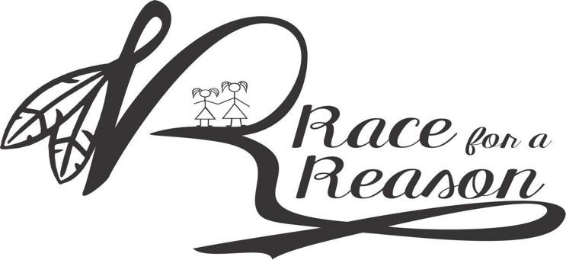

In appreciation of all the support we received last year, we asked for your votes to help us choose a recipient to receive a donation on behalf of The Cloverleaf Sale. By coming up with The Cloverleaf Sale 50/50 we have been able to visualize making a big impact on a great cause!

2018 Donation Recipient:
RACE FOR A REASON,
Raising money for The MSA Coalition. Please head over to their website to learn why this organization is so deserving.
www.multiplesystematrophy.org

What you need to know:
- Koozies cost $20
- We can ship them to you for $2
- Draw will take place on October 27, 2018
- Draw will be at 6pm prior to The Cloverleaf Sale Live Auction
- Be 1 of the first 2500 to purchase a Koozie and be entered to win a 4 day trip for 2 into the mountains on horseback with Horseback Adventures Ltd- valued at $2760.00⛰
- Be sure to check them out at www.horseback-adventures.com
- You must be a Canadian resident to win🇨🇦
- You must be of legal age in your province to win
- To purchase a Koozie you can purchase in person or by Etransfer.
- Please email ETransfers to katie.vinson@hotmail.com password: contest
- If ETransfering please be sure to add your name, mailing address and phone number in the comments.
- Full contest details can be found on our website www.threestepquarterhorses.com

Stay updated on our Facebook page “The Cloverleaf Sale 2018”. For a full set of contest rules please visit our website: www.threestepquarterhorses.com. Contest ends on October 27, 2018 at the start of The Cloverleaf Sale Live Auction. All prize claims must be redeemed by October 29, 2018. For no purchase entry, send postage paid, self-addressed stamped envelope to 3 Step Ltd, P.O. Box 72, Brule, AB T0E0C0, which must be postmarked by October 17, 2018 and received by October 23, 2018. Only open to residents of Canada. Void where prohibited. Correctly answered skill-testing question required. Complete Contest Rules, including approximate odds available at threestepquarterhorses.com. Contest Sponsor: 3 Step Ltd
The Contest Sponsor reserves the right to suspend, cancel or modify the contest at any time. No purchase necessary
HOW TO PLAY:
- Commencing on or about April 1, 2018, followers and guests of The Cloverleaf Sale 2018 in Canada may received one specially marked The Cloverleaf Sale Can Ticket (each, a “Ticket”)with the purchase of the corresponding The Cloverleaf Sale Can Koozie while supplies last. Each Ticket will provide a contest entry (each, a “Entry”). Not open where prohibited by law.

*Winner will be drawn on October 27, 2018 at the stat of The Cloverleaf Sale Live Auction. Winner will be required to answer a skill-testing question, in the event the winner wrongfully answers the question another participant will be drawn.

- NO PURCHASE NECESSARY TO PLAY: To obtain a FREE Ticket and/or a copy of the official rules, by writing to: 3 Step Ltd, P.O. Box 72, Brule, Alberta T0E0C0.

All requests for a Free Ticket must be postmarked by October 17, 2018 and received by October 22, 2018. Limit of one request per envelope with sufficient postage, while supplies lasts. No mechanical reproductions of requests permitted. All requests must include a postage-paid, self-addressed envelope.

CONTEST TICKETS
- A maximum of 5000 Tickets will be produced for this contest. Tickets will be available for distribution through to July 27, 2018 or while supplies last, whichever occurs first.

Contest Tickets available through the Facebook Page “The Cloverleaf Sale 2018” or by Contest Sponsor Representative.

Maximum prize estimated to be $50,000.00, maximum donation estimated to be $20,000.00

50% of total proceeds will be made payable to the winner in the form of a cheque produced by Contest Sponsor. 20% of total proceeds will be made payable to the winner in the form of a cheque produced by Contest Sponsor. 30% of total proceeds that the Contest Sponsor will retain will be put towards prizes, added payout and expensesThe Cloverleaf Sale currently depends on the entry fees of the consignment horses, race contestants and stallion service consignments in order to bring you this event. By adding this contest we are able to secure additional funds to make sure we deliver the quality and expectation of this event year after year. This contest allows the Contest Sponsor to give a helping hand and create an opportunity to help others succeed with the added support on behalf of The Cloverleaf Sale.

ODDS OF WINNING
- At the outset: the overall approximate odds in Canada of being eligible to win the $50,000.00 prize are 1 in 5000.

GENERAL RULES:
- Contest commences on or around April 1, 2018 and Tickets will be available through the Facebook Page “The Cloverleaf Sale 2018” or by a Contestant Sponsor Representative through October 27, 2018 or while supplies last, whichever occurs first. To be eligible, prize must be claimed within 48 hours or by 12:00 pm CT

- Contest TICKETS obtained through unauthorized sources or which are incomplete, mutilated, altered, reproduced, forged, counterfeited or irregular in any way, are automatically void. No TICKET copies, duplicates or reproductions of any type will be eligible for the contest. Contest Sponsor is not responsible for any lost TICKETS
- Prize claimant must be a resident of Canada. To be eligible to claim the Prize, Prize claimants must have reached the age of majority in their province/territory of residence or in the event a person under the of majority receives an eligible winning Ticket, they are permitted to transfer such Ticket to their parent or legal guardian, who will then be the eligible entrant.

- Employees, representatives, or agents of, or those domiciled with an employee, representative or agent of, 3 Step Ltd (the “Contest Sponsor”) are not eligible to participate. Employees, representatives, or agents of 3 Step Ltd as described in this paragraph are limited to those employees, representatives or agents who are providing services in anyway to 3 Step Ltd.

- By participating in this contest , entrants agree to be bound by these official rules and all decisions of the Contest Sponsor are final. Without limitation , Contest Sponsor reserves the right to administer an alternate skill-testing question as it deems appropriate to address discrimination or disability issues.

- Prize may not be exactly as shown in promotional materials. In case of unsold Tickets, or for any other reason and in Contest Sponsor’s sole discretion.

- The confirmed winner will be notified by and/or will received their Prize from 3 Step Ltd. All Prize claims become the property of the Contest Sponsor and no correspondence will be entered into except with potential and confirmed winners. By participating in this contest, confirmed winners are deemed to have consented to the disclosure of their personal information to Prize suppliers for the limited purpose of delivery of Prize and registration for warranty (as applicable). By entering this consent, each entrant expressly consents to Contest Sponsor, its agents, and/or representatives, storing, sharing and using the personal information only for the purpose of administering the contest.

- By claiming a Prize , Prize claimant consent the use of their name and/or photograph, and/or place of residence, without further compensation, in any publicity carried out by the Contest Sponsor.

- By accepting a prize, winner release Contest Sponsor, and their respective officers, directors, employees and agents, including, without limitation , their advertising and promotional agencies and independent contest organizations (“Releasees”), from any and all liability, loss or damage incurred with respect to the awarding, receipt, possession and/or use or misuse of any Prize and acknowledge that the Releasees have neither made nor are in any manner responsible or liable for any warranty, representation or guarantee, express or implied in fact or in law, including but not limited to its quality, mechanical condition or fitness for a particular purpose.

- In Quebec, any litigation respecting the conduct or organization of this publicity contest may be submitted to the Regie des alcools, des courses et des juex (“Regie”)for ruling. Any litigation respecting the awarding of a prize may be submitted to the board only for the purpose of helping the parties reach a settlement.

- The Contest Sponsor reserves the right to suspend, cancel or modify the contest at any time, subject to the approval of the Regie des alcools, des courses et des juex in Quebec, if it determines that for any reason the contest cannot be run as originally planned or for any other occurrence compromising the fairness or integrity of the contest.

- In the event there is a discrepancy or inconsistency between the English language version and any other language version of these rules or any contest, materials the English version shall prevail, govern and control. In the event there is a discrepancy or inconsistency between disclosures or other statements contained in any contest materials and the terms and conditions of these rules, these rules shall prevail, govern and control.

HOW TO CLAIM PRIZE
- If you are eligible to win a Prize and are not in attendance of The Cloverleaf Sale live Auction, COMPLETE PRIZE CLAIM FORM. Upon receipt, the Contest Sponsor will then contact the potential winner by telephone. Completed Claim Form (attached to these rules, extra copies available at www.threestepquarterhorses.com) and send (using an envelope with sufficient postage, which must be postmarked on, or before, October 29, 2018 and received at the following address by no later than November 14, 2018) to: 3 Step Ltd P.O. Box 72, Brule, AB T0E0C0. In order to be declared a winner, you must have correctly answered a STQ. Upon receipt of your complete Prize Claim Form, the Contest Sponsor will verify your prize claim.

IMPORTANT NOTE:
- For eligible winners we STRONGLY RECOMMEND sending all Prize claim materials by REGISTERED MAIL, and keep a copy of prize claim forms for your records, as we will not be responsible for lost or delayed Prize claims.

